InvasivesBC - Load testing

The purpose of this document is to outline the outcome of the recent conversation with the other teams to come up with a solution to do load testing on our API side

## Loadtest

It is recommended to use the npm package **loadtest** to test our API in terms of load. It is very straightforward and to use. Also, it can be integrated easily with our current testing framework (Mocha) or any other frameworks as well

A detailed documentation and an example on how to use it can be found [here](https://www.npmjs.com/package/loadtest)

**Additional Context**

From Jeff Arctiq,

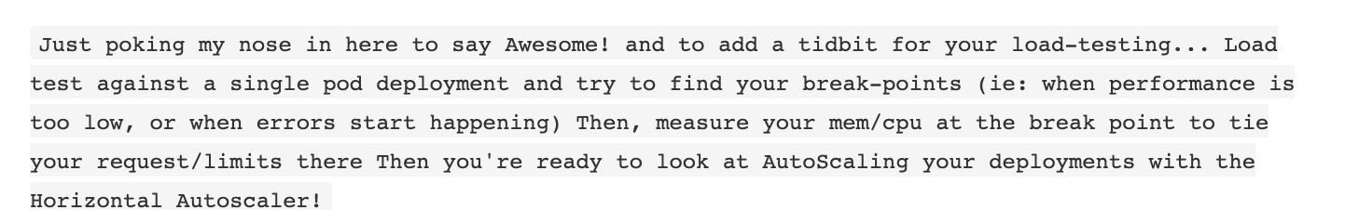

<https://docs.openshift.com/container-platform/3.11/dev_guide/pod_autoscaling.html>